|  |  |  |
| --- | --- | --- |
|  | **GUJARAT TECHNOLOGICAL UNIVERSITY**  Chandkheda, Ahmedabad  Affiliated |  |

Sardar Vallabhbhai Patel Institute of Technology

Vasad-041

A

Project Report

On

**Food Scanner**

Under Subject of

**DESIGN ENGINEERING – 1B**

B. E. II, Semester – IV

**(Information Technology)**

***Submitted by:***

Team ID:35475

|  |  |  |
| --- | --- | --- |
| **Sr.** | **Name of student** | **Enrolment No.** |
|  |  |  |
| 1 | Matroja Karansinh | 160410116055 |
| 2 | Meghpara Jeetkumar | 160410116056 |
| 3 | Kansara Kaushiki | 160410116048 |
|  |  |  |
|  |  |  |

|  |  |
| --- | --- |
| **Prof.**  **Amit Kariyani**  **(Faculty Guide)** | **Prof.**  **N.V. Shah**  **(Head Of Department)** |

**Academic year**

**(2017-2018)**

|  |  |  |
| --- | --- | --- |
|  | **GUJARAT TECHNOLOGICAL UNIVERSITY**  Chandkheda, Ahmedabad  Affiliated |  |

**CERTIFICATE**

This is to certify that the students namely, **Karansinh Matroja (160410116055), Jeet Meghpara (160410116056), and Kaushiki Kansara (160410116048)** of

***B. E. (Information Technology) Semester IV*** have successfully completed the course work and related tasks for the course of **Design Engineering 1B (2130005)** during the academic term ending in the month of April 2018.

Date of submission: 23-04-2018

Place: SVIT VASAD

**Prof. Mr. Amit Kariyani Prof. Mrs. N. V. Shah**

Head of the Department

**(Faculty in charge) (Internal Examiner) (External Examiner)**

Contents

[1. Introduction 1](#_Toc512230255)

[2. Canvases 2](#_Toc512230256)

[2.1. AEIOU Canvas 2](#_Toc512230257)

[2.1.1. Activity 2](#_Toc512230258)

[2.1.2. Environment 2](#_Toc512230259)

[2.1.3. Interactions 3](#_Toc512230260)

[2.1.4. Objects 3](#_Toc512230261)

[2.1.5. Users 3](#_Toc512230262)

[2.2. Empathy Mapping Canvas 4](#_Toc512230263)

[2.2.1. Users: 5](#_Toc512230264)

[2.2.2. Stakeholders: 5](#_Toc512230265)

[2.2.3. Activity: 5](#_Toc512230266)

[2.3. Ideation Canvas 6](#_Toc512230267)

[2.3.1. People 6](#_Toc512230268)

[2.3.2. Activity 6](#_Toc512230269)

[2.3.3. Situation/Context/Location 7](#_Toc512230270)

[2.3.4. Props/Possible Solution 7](#_Toc512230271)

[2.4. Product Development Canvas 8](#_Toc512230272)

[2.4.1. Purpose 8](#_Toc512230273)

[2.4.2. People 8](#_Toc512230274)

[2.4.3. Production Functions 9](#_Toc512230275)

[2.4.4. Product Features 9](#_Toc512230276)

[2.4.5. Customer Revalidation 9](#_Toc512230277)

[2.4.6. Retain, Reject or Redesign 9](#_Toc512230278)

[2.5. Mind Mapping Canvas 10](#_Toc512230279)

[3. Feedbacks 11](#_Toc512230280)

[4. Summary of findings of Prior Art Search on our project theme 12](#_Toc512230281)

[5. Summary of Learning from reverse Engineering Activity 19](#_Toc512230282)

[6. Learning Need Matrix 20](#_Toc512230283)

[7. Rough Prototype Model 22](#_Toc512230284)

# Introduction

Now a day we observe the many foods related health problems increasing day by day due to increasing in food quality issues. We rarely find healthy, hygiene and pure food. When we go outside the country we did not know about the exact food items used in dishes. And sometimes we are clearly unable to recognize the food.

So, consider all this food related issues, we worked on it and decided to develop basic food scanner which can scan your food to deliver accurate information.

This scanner is easy and simple to use. All we have to do is take a picture of that food item. The computer algorithm works on it. And shows us all the relevant information about it like it’s origin, nutritional facts, calories etc. Apart from this it also provides Diet Planning, Allergy Checking and what quantity you eat.

# Canvases

## AEIOU Canvas

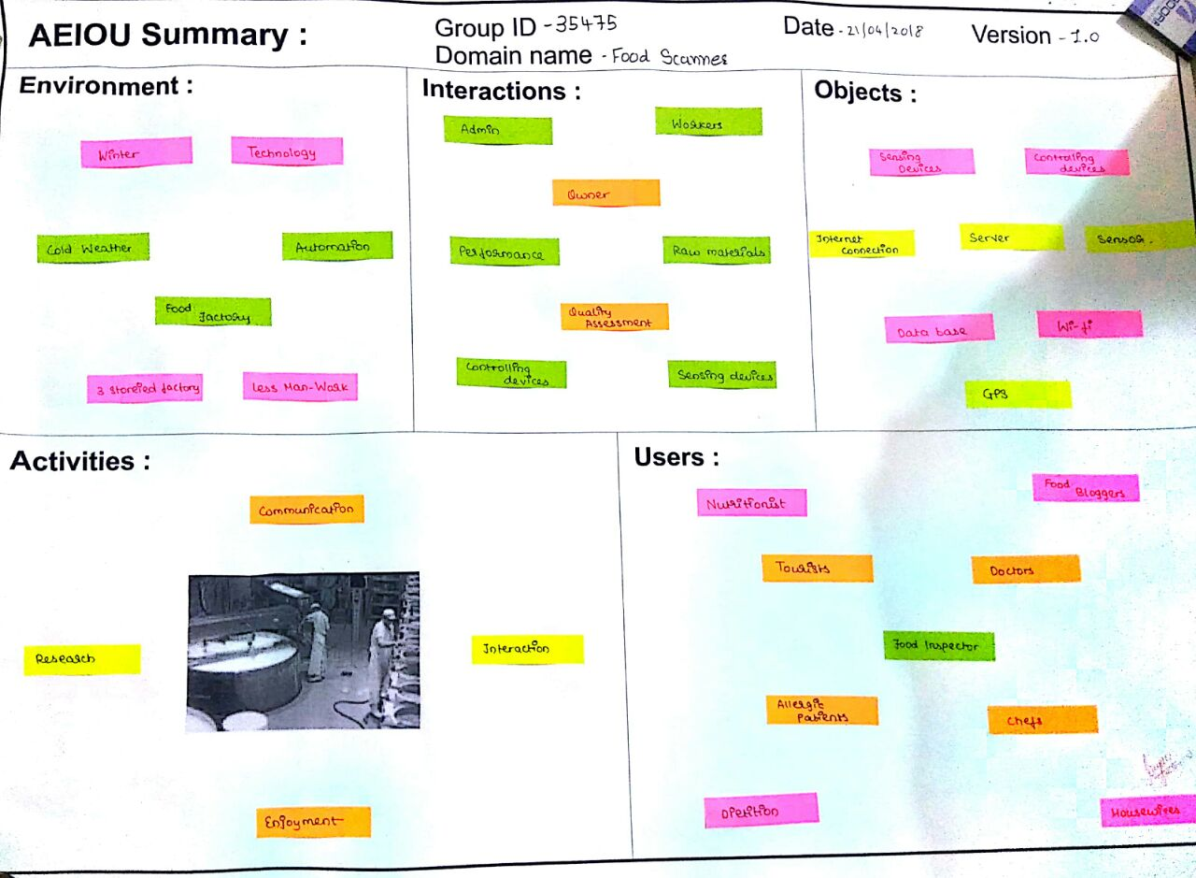

We will discuss some points which are covered in this canvas.

### Activity

* When we visited in food laboratory we communicate with managers and workers include every staff member and try to know about their work and how food proceed in their laboratory.
* We saw that how they check food quality and how they differentiate food by their quality and then according to use they do process on that and used that food.
* We also saw all company worker’s engagement with their works.

### Environment

* Weather
* Technology used in food processing system
* Automation -all work done by machines and only one man handles with commuter that all machines
* Food Storage machines

### Interactions

At food factory we communicate with many people like.

* Admin
* Manager
* Workers

Work done by those peoples

* Raw materials checking
* Quality assessment
* Control the devices

### Objects

Objects which are used in food sensor

* Sensing devices
* Controlling devices
* Connectors
* GPS
* Wi-Fi
* Internet connection
* Database

### Users

Mostly food scanner used by these persons

* Food inspector
* Dietitian
* Chefs
* Doctors
* Food blogger

## Empathy Mapping Canvas

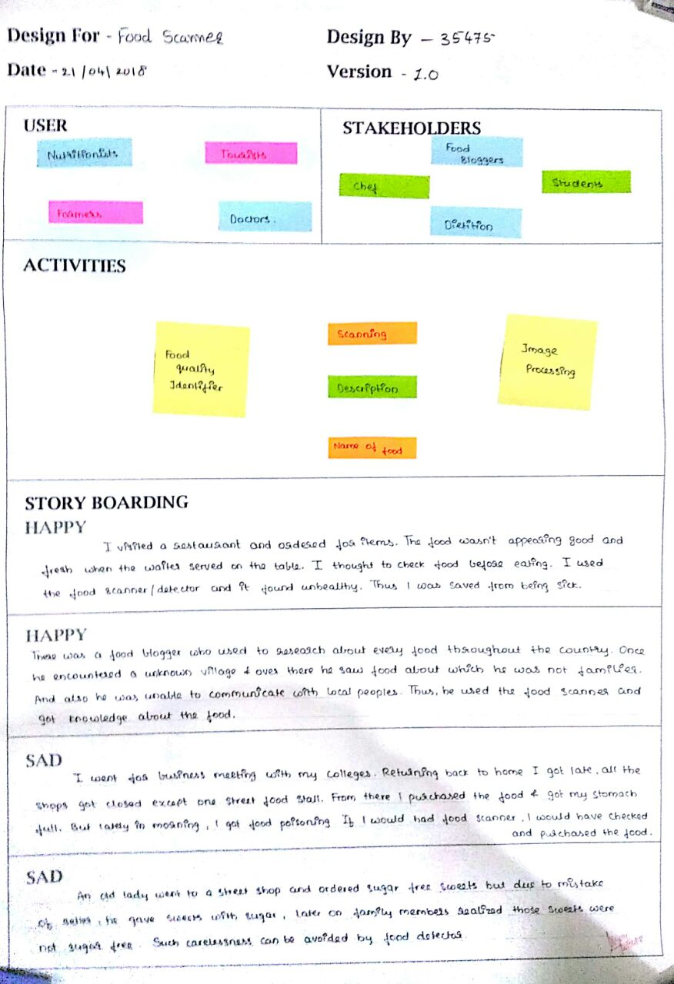

Here we are going to explain users, stack holders and activity. And here we are discussing about happy story and sad story which indicate how food scanner helps us.

### Users:

* Tourist
* Engineer
* Doctor
* Farmer

### Stakeholders:

* Chef
* Food blogger
* Student
* Dietitians

### Activity:

* Food quality identifier
* Scanning
* Name of food
* Description
* Image processing

## Ideation Canvas

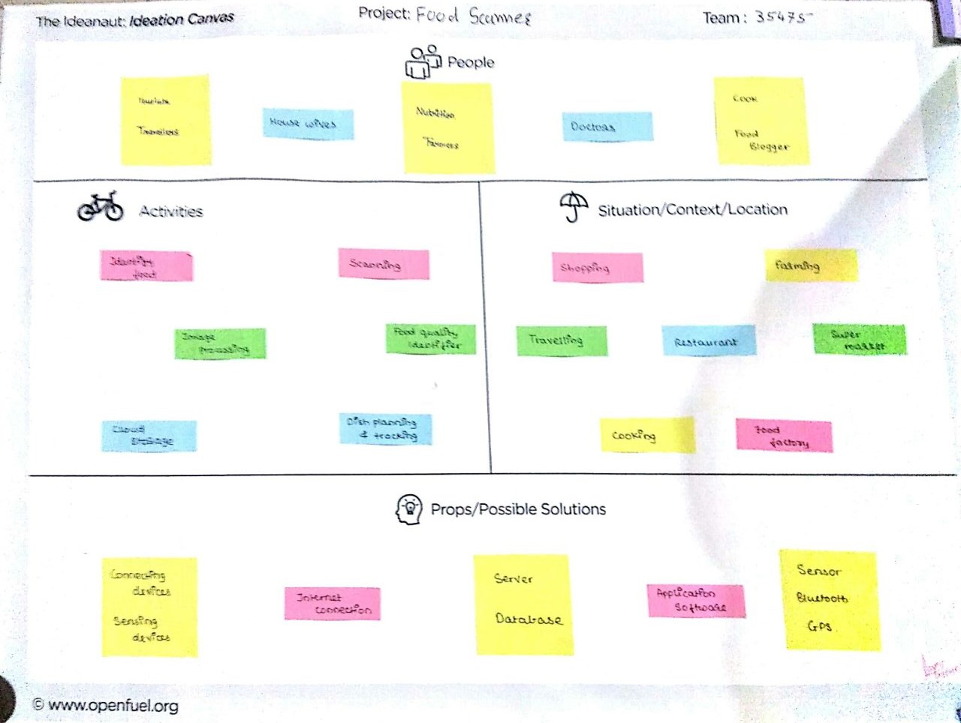

Here we are describing people, and activities of people, situation, location, and what types of problems face by peoples and their solution.

### People

* Nutrition
* Tourist
* Traveler
* Doctor

### Activity

* Scanning
* Description
* Image processing
* Cloud storage
* Identity of food
* Food quality identifier
* Allergy identifier

### Situation/Context/Location

* Shopping
* Farming
* Travelling
* Super market
* Restaurant
* Food factory
* Cooking

### Props/Possible Solution

* Sensor
* Bluetooth
* GPS
* Application software
* Server
* Wi-Fi
* Database

## 2.4. Product Development Canvas

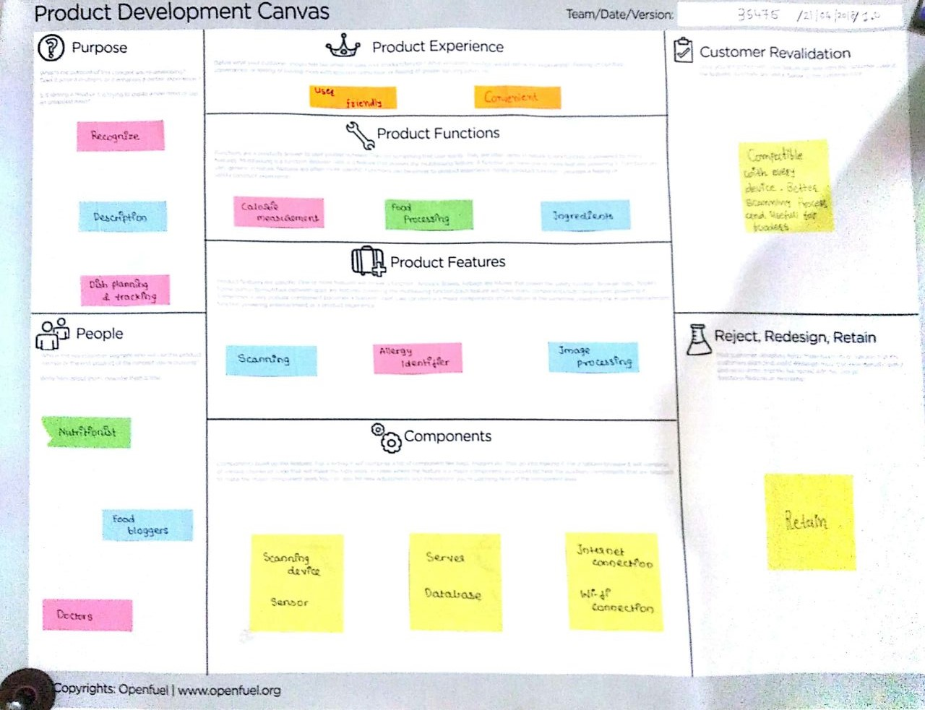

This canvas shows the purpose of food scanner, people, product functions of food scanner, components of food scanner.

### Purpose

Food scanner is giving you the whole Description of particular scanning food.

Food scanner helps you to Recognizing food.

### People

Nutrition

Doctors

Food blogger

Tourists

Farmers

### Production Functions

Food processing

Ingredients

Calorie measurement

### Product Features

Scanning

Image processing

Origin

Nutrition information

Allergy identifier

### Customer Revalidation

Compactable with every device. Better scanning process and useful for fooders.

### Retain, Reject or Redesign

Retain

## Mind Mapping Canvas

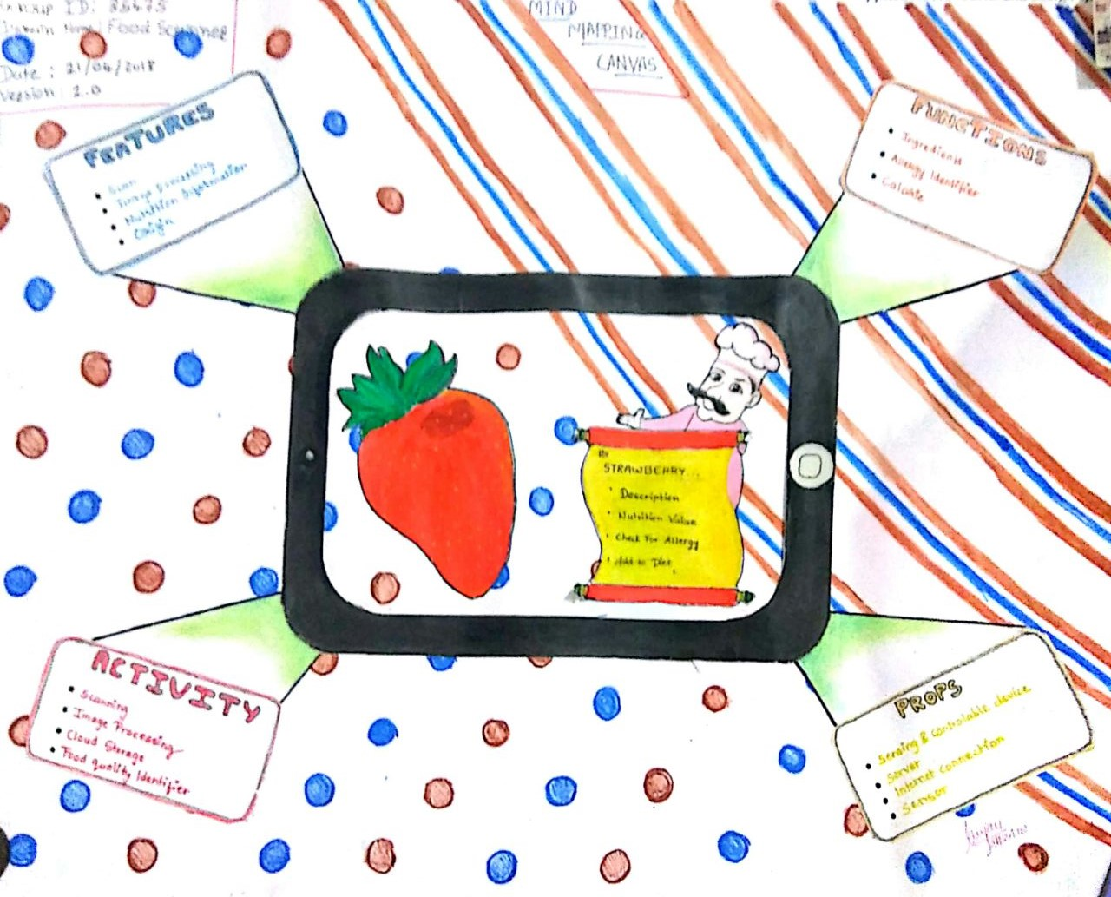

Here we can see the 4 features of food scanner in mind mapping.

* Props

Sensors and Controlling Devices, Server and Internet Connection.

* Activity

Scanning, Image Processing, Cloud Storage and Food Quality Identifier.

* Functions

Ingredients, Allergy Prevention and Calorie Counter.

* Features

Scan, Nutrition Information, Origin and Image Processing.

# Feedbacks

A nice simple app that works as stated. Although there is not a lot of product information. I love the concept of Food Scanner. For anyone looking at using this app then I suggest having a look at the Internet as that explains more on how to get involved. This app has lots of potential, particularly for detailing allergy information. This is something I am definitely going to look at contributing to.

A Barcode Scanning option was needed; else everything is fine.

There should be an option for searching food via names too.

Only Indian Cuisine is there in the Database, what about other cuisines?

# Summary of findings of Prior Art Search on our project theme

Smartphone Based Food Diagnostic Technologies

A new generation of mobile sensing approaches offers significant advantages over traditional platforms in terms of test speed, control, low cost, ease-of-operation, and data management, and requires minimal equipment and user involvement. The marriage of novel sensing technologies with cell phones enables the development of powerful lab-on-smartphone platforms for many important applications including medical diagnosis, environmental monitoring, and food safety analysis. This paper reviews the recent advancements and developments in the field of smartphone-based food diagnostic technologies, with an emphasis on custom modules to enhance smartphone sensing capabilities. These devices typically comprise multiple components such as detectors, sample processors, disposable chips, batteries and software, which are integrated with a commercial smartphone. One of the most important aspects of developing these systems is the integration of these components onto a compact and lightweight platform that requires minimal power. To date, researchers have demonstrated several promising approaches employing various sensing techniques and device configurations. We aim to provide a systematic classification according to the detection strategy, providing a critical discussion of strengths and weaknesses. We have also extended the analysis to the food scanning devices that are increasingly populating the Internet of Things (IoT) market, demonstrating how this field is indeed promising, as the research outputs are quickly capitalized on new start-up companies.

Food scanners are hand-held devices that are able to analyze the composition of food with a simple point and shoot.

In March last year, the European Commission awarded a [food scanner innovation prize](http://ec.europa.eu/research/horizonprize/index.cfm?prize=food-scanner&pg=finalists). It was part of their Research Innovation Horizon Prizes, with three successful finalists.

The winner was the Finnish start up [Spectral Engines](https://www.spectralengines.com/products/scanner-platform/foodscanner/). Founded in 2014, the start-up developed a food scanner based on Near Infrared Spectroscopy. With advanced algorithms and cloud-connectivity and a vast library, it can "see" a lot. According to the company, it can ["reveal the fat, protein, sugar and total energy content"](https://www.spectralengines.com/products/scanner-platform/foodscanner/) of foods.

Other Food Scanners

These scanners are different in that they are unique portable devices. But other companies have also tried to develop food scanners as mobile apps.

These work differently and have focused around calorie scanners and macronutrients scanners. For instance, [MyFitnessPal](https://www.myfitnesspal.com/) has an app called Calorie Counter that does just this. With millions of dishes in their database and the possibility to scan barcodes, they made figuring out exactly what you're putting into your body easier.

Applications:

Preventing allergic reactions:

These whether they come in the form of scanning apps or scanning devices, they have a lot of potential.

For many people with allergies to specific foods, they can help save numerous lives. [According to Food Allergy Research & Education](https://www.foodallergy.org/life-food-allergies/food-allergy-101/facts-and-statistics), 1 in 13 children in the US alone have food allergies. And about 30% of these are allergic to more than one food. In the US, food allergies send over 200,000 people to emergency rooms a year - one person every 3 minutes. And there's no cure except for avoiding these foods.

But, in many situations, it's impossible to avoid them altogether. This becomes even harder when on vacation abroad or when eating out. Food scanners can provide valuable warning signs prior to ingesting food.

Controlling your weight and eating what's right for you:

But even for those without food allergies, they can be useful. They could potentially be used to count the calories you're about to ingest, in case you're trying to lose a little weight. While some apps already help with this by scanning the barcodes or choosing the dish you are eating, they are not infallible. But in the future, this may change.

On top of that, with the progress in the fields of [genetics and biotech](https://www.futuresplatform.com/theme/human-enhancement), you may soon get a complete read of what foods are good for you and which you should avoid. For instance, you may figure out you are too sensitive to caffeine or that you should avoid eating more than 1 egg per day. Using molecular food scanners, you could get accurate information on the content of the foods you are eating. And avoid things you shouldn't eat.

The Promise and Problems of Food Scanners

A new generation of mobile sensing approaches offers significant advantages over traditional platforms in terms of test speed, control, low cost, ease-of-operation, and data management, and requires minimal equipment and user involvement. The marriage of novel sensing technologies with cell phones enables the development of powerful lab-on-smartphone platforms for many important applications including medical diagnosis, environmental monitoring, and food safety analysis. This paper reviews the recent advancements and developments in the field of smartphone-based food diagnostic technologies, with an emphasis on custom modules to enhance smartphone sensing capabilities. These devices typically comprise multiple components such as detectors, sample processors, disposable chips, batteries and software, which are integrated with a commercial smartphone. One of the most important aspects of developing these systems is the integration of these components onto a compact and lightweight platform that requires minimal power. To date, researchers have demonstrated several promising approaches employing various sensing techniques and device configurations. We aim to provide a systematic classification according to the detection strategy, providing a critical discussion of strengths and weaknesses. We have also extended the analysis to the food scanning devices that are increasingly populating the Internet of Things (IoT) market, demonstrating how this field is indeed promising, as the research outputs are quickly capitalized on new start-up companies.

A device, *[SCiO](https://www.consumerphysics.com/myscio/" \t "_blank)*, from Israel, was founded by people with optical engineering backgrounds. They have raised over $2.7 million on Kickstarter in 2014. It uses a technology similar to *TellSpec*’s but is designed to identify the molecular content of foods, medicines, and even plants. It illuminates an object; optical sensors detect the reflected light; and the device analyzes it using an algorithm and a cloud–based database that is constantly updated. The company promises that in milliseconds the ingredients and molecular make–up of the foodstuff will appear on the user’s smartphone. The device was scheduled for shipment in 2015, but disappointed backers, but still hasn’t shipped. On top of the delays, experts in applied science criticized both SCiO and TellSpec for overstating what their inventions can do.

There are two major issues. One is size, because the device must be hand–held to become popular. With current technology this means engineers have to sacrifice sensitivity and accuracy in order to achieve a convenient size. The other issue is the algorithm. *SCiO* sends data to the cloud which then sends its calculation back to the device. But to simplify what the algorithm has to do, users need to tell the scanner specifics – like whether the sample is a solid food, a liquid, or vegetable. These inconveniences are the price of keeping the scanner small.

There isn’t any promising hand–held food scanners on the horizon besides these, but there is no reason to believe a solution will not arise in the coming years. The challenge is not when a workable device comes along but what we will do with the large amount of data it generates.

Diabetes patients would know how many carbohydrates their food contains. But knowledge doesn’t change behaviour alone, otherwise nobody would smoke by now. Knowledge supported by gaming or technologies revealing our lifestyle choices to our family members or caregivers might do. Patients with rare genetic metabolic disorders such as phenylketonuria would know what to avoid at all cost. People with allergies could avoid dangerous meals. Having a good diet would not rely on the experience we bring with us from childhood and what we have learned since then. Instead, it could be based on informed decisions.

Research on Food Scanners

This paper reviews the recent advancements and developments in the field of smartphone-based food diagnostic technologies, with an emphasis on custom modules to enhance smartphone sensing capabilities. These devices typically comprise multiple components such as detectors, sample processors, disposable chips, batteries and software, which are integrated with a commercial smartphone. One of the most important aspects of developing these systems is the integration of these components onto a compact and lightweight platform that requires minimal power. To date, researchers have demonstrated several promising approaches employing various sensing techniques and device configurations. We aim to provide a systematic classification according to the detection strategy, providing a critical discussion of strengths and weaknesses. We have also extended the analysis to the food scanning devices that are increasingly populating the Internet of Things (IoT) market, demonstrating how this field is indeed promising, as the research outputs are quickly capitalized on new start-up companies.

A device, *[SCiO](https://www.consumerphysics.com/myscio/" \t "_blank)*, from Israel, was founded by people with optical engineering backgrounds. They have raised over $2.7 million on Kickstarter in 2014. It uses a technology similar to *TellSpec*’s but is designed to identify the molecular content of foods, medicines, and even plants. It illuminates an object; optical sensors detect the reflected light; and the device analyzes it using an algorithm and a cloud–based database that is constantly updated. The company promises that in milliseconds the ingredients and molecular make–up of the foodstuff will appear on the user’s smartphone. The device was scheduled for shipment in 2015, but disappointed backers, but still hasn’t shipped. On top of the delays, experts in applied science criticized both SCiO and TellSpec for overstating what their inventions can do.

There are two major issues. One is size, because the device must be hand–held to become popular. With current technology this means engineers have to sacrifice sensitivity and accuracy in order to achieve a convenient size. The other issue is the algorithm. *SCiO* sends data to the cloud which then sends its calculation back to the device. But to simplify what the algorithm has to do, users need to tell the scanner specifics – like whether the sample is a solid food, a liquid, or vegetable. These inconveniences are the price of keeping the scanner small.

There isn’t any promising hand–held food scanners on the horizon besides these, but there is no reason to believe a solution will not arise in the coming years. The challenge is not when a workable device comes along but what we will do with the large amount of data it generates.

Diabetes patients would know how many carbohydrates their food contains. But knowledge doesn’t change behavior alone, otherwise nobody would smoke by now. Knowledge supported by gaming or technologies revealing our lifestyle choices to our family members or caregivers might do. Patients with rare genetic metabolic disorders such as phenylketonuria would know what to avoid at all cost. People with allergies could avoid dangerous meals. Having a good diet would not rely on the experience we bring with us from childhood and what we have learned since then. Instead, it could be based on informed decisions.

Food based Diagnostic Technologies

Food scanners are hand-held devices that are able to analyses the composition of food with a simple point and shoot.

In March last year, the European Commission awarded a [food scanner innovation prize](http://ec.europa.eu/research/horizonprize/index.cfm?prize=food-scanner&pg=finalists). It was part of their Research Innovation Horizon Prizes, with three successful finalists.

The winner was the Finnish startup [Spectral Engines](https://www.spectralengines.com/products/scanner-platform/foodscanner/). Founded in 2014, the startup developed a food scanner based on Near Infrared Spectroscopy. With advanced algorithms and cloud-connectivity and a vast library, it can "see" a lot. According to the company, it can ["reveal the fat, protein, sugar and total energy content"](https://www.spectralengines.com/products/scanner-platform/foodscanner/) of foods.

Other Food Scanners

These scanners are different in that they are unique portable devices. But other companies have also tried to develop food scanners as mobile apps.

These work differently and have focused around calorie scanners and macronutrients scanners. For instance, [MyFitnessPal](https://www.myfitnesspal.com/) has an app called Calorie Counter that does just this. With millions of dishes in their database and the possibility to scan barcodes, they made figuring out exactly what you're putting into your body easier.

Applications:

Preventing allergic reactions:

These whether they come in the form of scanning apps or scanning devices, they have a lot of potential.

For many people with allergies to specific foods, they can help save numerous lives. [According to Food Allergy Research & Education](https://www.foodallergy.org/life-food-allergies/food-allergy-101/facts-and-statistics), 1 in 13 children in the US alone have food allergies. And about 30% of these are allergic to more than one food. In the US, food allergies send over 200,000 people to emergency rooms a year - one person every 3 minutes. And there's no cure except for avoiding these foods.

But, in many situations, it's impossible to avoid them altogether. This becomes even harder when on vacation abroad or when eating out. Food scanners can provide valuable warning signs prior to ingesting food.

Controlling your weight and eating what's right for you:

But even for those without food allergies, they can be useful. They could potentially be used to count the calories you're about to ingest, in case you're trying to lose a little weight. While some apps already help with this by scanning the barcodes or choosing the dish you are eating, they are not infallible. But in the future, this may change.

On top of that, with the progress in the fields of [genetics and biotech](https://www.futuresplatform.com/theme/human-enhancement), you may soon get a complete read of what foods are good for you and which you should avoid. For instance, you may figure out you are too sensitive to caffeine or that you should avoid eating more than 1 egg per day. Using molecular food scanners, you could get accurate information on the content of the foods you are eating. And avoid things you shouldn't eat.

A new generation of mobile sensing approaches offers significant advantages over traditional platforms in terms of test speed, control, low cost, ease-of-operation, and data management, and requires minimal equipment and user involvement. The marriage of novel sensing technologies with cellphones enables the development of powerful lab-on-smartphone platforms for many important applications including medical diagnosis, environmental monitoring, and food safety analysis. This paper reviews the recent advancements and developments in the field of smartphone-based food diagnostic technologies, with an emphasis on custom modules to enhance smartphone sensing capabilities. These devices typically comprise multiple components such as detectors, sample processors, disposable chips, batteries and software, which are integrated with a commercial smartphone. One of the most important aspects of developing these systems is the integration of these components onto a compact and lightweight platform that requires minimal power. To date, researchers have demonstrated several promising approaches employing various sensing techniques and device configurations. We aim to provide a systematic classification according to the detection strategy, providing a critical discussion of strengths and weaknesses. We have also extended the analysis to the food scanning devices that are increasingly populating the Internet of Things (IoT) market, demonstrating how this field is indeed promising, as the research outputs are quickly capitalized on new start-up companies.

# Summary of Learning from reverse Engineering Activity

In the 3rd semester, we have learnt the basic Design Thinking methodology in DE-1A and undergone the phases of the same with necessary tools and techniques using various framework and canvases. In 3rd semester, we have worked upon general topic/domain irrespective of their branch, now in 4th semester we need to select branch specific existing artefact/component for Reverse Engineering and modify/redesign it as per the User’s needs using Design Thinking.

There are two basic objectives of introducing RE:

1. We will learn some basic concept from our branch and relate all stages/phases of Design Engineering with the regular core subjects of particular branch in current or further semester/s as one of the key objectives of Design Engineering subject is to absorb Design Thinking approach into core engineering subject for practical learning.
2. We will use Design Thinking process again to refine the learning.

In this module also whole Design Thinking process will be used by us, but more emphasis on Ideation and initial Product Development phase.

# Learning Need Matrix

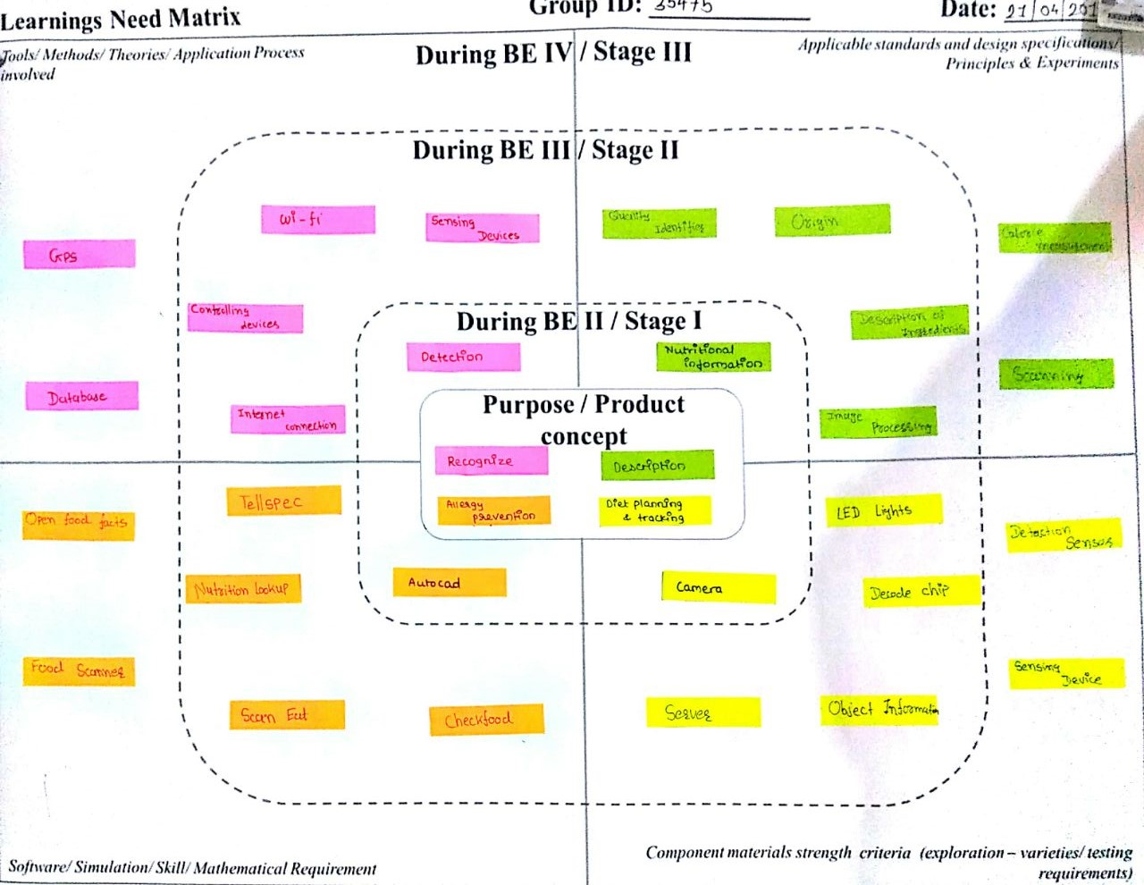

We students, with the guidance of our Faculty Guide, need to identify at this stage, the needs for the generic learning, required while we develop their idea. The learning requirements will depend upon and may be specific for the concept/idea for our solution. This will help us to do the research in a timely manner so that we are able to obtain the specific learning/ understanding, we would require for designing the product. With understanding of the basic branch/ project related subjects, (after having discussions with and the guidance of our Faculty Guide) we will be able to identify tools/ use of software/ applicable standards/ material / design specifications/ theories/ principles/ methods/ experiments related needs to be acquired by us to complete our project successfully. After identifying the specific learning that will be required to develop our idea/product/concept further, we have to distribute learning requirements among the members of the group and each member has to learn minimum one component of LNM, in consultation with the Faculty Guide. We need to make LNM and include it in our report. LNM would include four major aspects as below:

1. Theories/ Methods/ Application Process Involved/ Mathematical Requirement
2. Applicable Standards and Design Specifications/ Principles & Experiments
3. Software/ Tools/ Simulation Methods/ Skill
4. Components Materials’ & strengths criteria (Exploration- varieties/testing requirements).

# Rough Prototype Model

